PULSE AC/DC TIG WELDER
INSTRUCTION MANUAL
THANK YOU FOR BUYING OUR PRODUCT, PLEASE
READ THIS INSTRUCTION MANUAL BEFORE USE AND
KEEP FOR FUTURE REFERANCE. PROPER USE WILL
BRING YOU MORE ECONOMIC BENEFIT!
1

EQUIPMENT INNOVATIONS
TA-200

Content
1． Safety Notice ----------------------------------------------------------------1
2． General Description -------------------------------------------------------3
3． Main technical Parameter ----------------------------------------------- 3
4． The panel’s function and parameter illustration ------------------- 4
5． Installation ------------------------------------------------------------------- 5
6． Operation ---------------------------------------------------------------------6
7． Attention Point --------------------------------------------------------------6
8． Welding Reference Value -------------------------------------------------8
9． Maintain and Check ---------------------------------------------------------9
10． Key Point For Check During Abnormal-----------------------------------10
11

1

1、Safety Notice
Danger！ In order to avoid accident, should accord with the following regulations
1． We fully consider safety when designing and making this machine. Should accord with the attention
points in this manual, or may cause physical accident.
2． Please accord with relative regulation and the domestic standards for construction of input of power
source, workplace, use and keeping and arrangement of high pressure gas, and keeping of
workpiece after welding, dispose of offal after welding.
3． Unrelated person shouldn’t get close to the welding work place.
4．People who are using pacemaker should not get close to working welder, nor around welding workplace,
because the magnetic wave generated when the welding power is on will cause adverse impact on it.
5． Should let people with professional knowledge to assemble, check and maintain welder.
6. In order to ensure safety, please comprehend the contents in this manual correctly, and ask the
person with safety knowledge and skill to operate machine.
7． Shouldn’t use this machine to do the work doesn’t relate with welding area.
Danger！ In order to avoid electric shock, please accord with the following regulations.
* If touching electrified parts besides secondary electrode causes electric shock
1． Please don’t touch any electrified part.
2． Please ask electrician to do earth connection for machine and material.
3． Should turn off power of Distribution Box 5 minutes before assembling or checking.
4． Shouldn’t use cable with insufficient capacity or the one with broken insulation cover.
5． Make sure of proper insulation for cable connection.
6． Shouldn’t use machine while its cover is taken apart.
7． Please use dry insulation gloves.
8． Please use safety net while working at high place.
9. Should maintain or check machine periodically and use after the damaged part is repaired.
10．If not use, should cut off the input power.
Attention！Avoid the welding smoke may injure you or other, should accord
with the following regulations.
* Smoke or gas generated from welding is hazardous to health.
* If operating in narrow place, will cause being suffocated due to oxygen deficiency.
1． In order to avoid accidents like gas poisoning and suffocation, please use regulated gas vent
equipment and wear breathing protecting tools.
2． When welding in bottom of Box place and oven and ship, the CO2 and Argon heavier than air will
keep in the bottom, so should change air well enough and wear breathing protecting tools.
3． Shouldn’t do welding in the degreasing, cleaning or spraying places.
4． May generate hazardous gas when welding steel with coating or painting layer, please wear
breathing protect tools.
1

Attention！ In order to avoid accidents like fire, blast, crack, should accord with
the following regulations
1． Shouldn’t place flammable substances near to welding place.
2． Shouldn’t do welding near to flammable gas.
3． Shouldn’t place heated material after welding near to flammable substances.
4． When welding dooryard, ground, wall, should clear off the flammable substances on cover.
5． The cable connection should be insulated well enough.
6． Connection of earth wire should be as nearest as possible to welding spot.
7． Shouldn’t weld the gas-filled tube or sealed tunnel.
8． In case of fire, should install fire extinguisher.
Attention！ Please wear regulated protecting tools, in case of being
injured by welding arc, splash, spatter and noise.
* Arc rays may cause eyes rankle or burn.
* Splash and spatter may burn eyes or skin.
1.
2.
Should wear protecting tools to shield arc rays when doing or supervising welding.
Should wear protecting glass.
Attention！ Touching rotating part may be injured, should accord with the
following regulation.
* Keep finger, hair and clothes away from the cooling fan.
1. Shouldn’t use welder while its cover is taken apart.
2． Should ask professional person to install, operate, check and maintain welder.
3． Shouldn’t let your fingers, hair or clothes get close to the cooling fan.
11
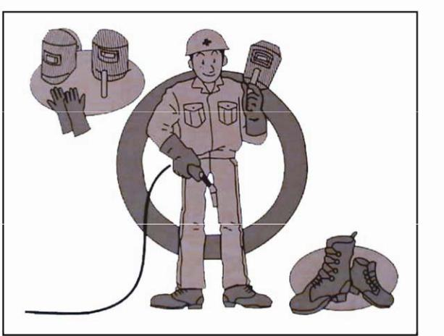

Attention！ In case that the insulation of welder deteriorates and cause fire,
should accord with the following regulations.
* If the welding splash or iron powder generated from polishing gets into welding power source,
it will lead to deterioration inside, and cause fire.
1． In case that welding splash or iron powder get into inside of welding power source, please isolate
welding machine from welding spot and polishing spot.
2． In case that powder accumulated inside and deteriorates insulation, should periodically maintain,
check machine. If the splash or iron powder gets into machine body, should power off machine and
Distribution Box, use dry air to clear them off.
2、 General Description
WSME series PULSE AC/DC tig welder adopts advanced Inverter Technology, easy to strike arc,
and arc is stable with quick dynamic feedback, perform high welding quality.
Figure：
● Adopt SCM digital control technology, with constant output current, stable welding current.
● High frequency arc strike function, easy to strike arc.
● Designed with protecting functions. When outer power supply is abnormal or welder works over
duty cycle, it can send warning signal and stop welding automatically.
● Compact，light，easy to carry.
● Digital panel, easy to operate.
● The preset current and actual one can convert automatically
● With the different welding ways, adjustable parameters automatically increase or decrease.
● Applicable for stainless steel, aluminum, carbon steel, alloy steel, copper and titanium. Widely used
in petrochemical industry, electricity, building and tube installment and machinery making etc.
3、 Main technical Parameter
Type
TA-200
Model
Rated Input Voltage (V)
1～220
Power Frequency (Hz)
Welding Current (A)
Rated Input Power (KVA)
No-load Voltage (V)
Rated Duty Cycle (%)
Cover Protection Class
Cooling Way
50/60
5～200
4.7
70
70
IP21
Fan-cooling
Dimension (mm)
487*230*380
20
Weight (kg)
11

4、 The panel’s function and parameter illustration
The panel function illustration：
No
Name
Explain
Choose welding mode under different function. The standard for "no arc"
function, gradient "crater" function.
1
Choose welding function
Choose parameter left
key
Move left to determine the position of the indicator light for the preset
parameters.
2
3
Choose parameter right Move right to determine the position of the indicator light for the preset
key
parameters.
4
5
Display screen
Save key
To display the parameters.
To store the welding data and can store ten sets of different welding data.
6
7
8
Parameter adjusting knob
Adjust the preset parameters.
Adjust Key
Welding mode selection
key
The storage of different welding parameters were obtained.
Long press 3 secondson TIG, then release, can be converted to MMA
welding.
9
Waveform selection key
Choose three different welding output waveform.
10
11
AC/DC selection keys
Pulse function selection
key
DC, AC feature selection.
Choose the pulse and the composite pulse, and the composite pulse
function can be used in the AC condition.
12
13
High pressure indicator
Warning light
No-load voltage output indicator.
overheat, over current alarm indicator.
11
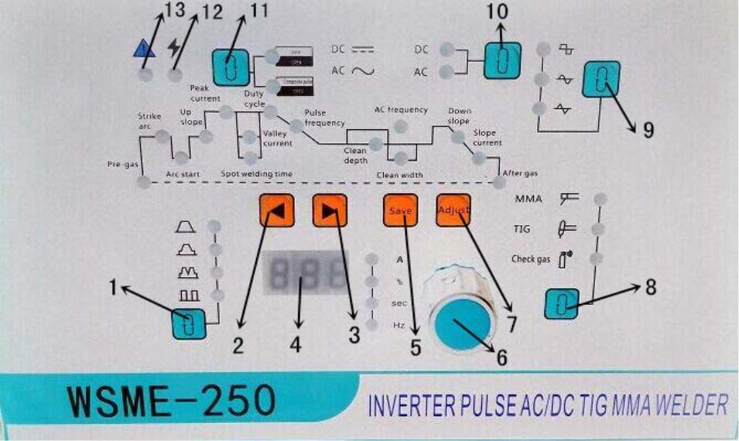

The panel parameter illustration：
Default
value
0.1 S
Name
Summary
Adjust range
Pregas
Arc strict
Arc start
Time of gas in advance
Arc moment current
0～10 S
5～200A
5～200A
100A
40 A
Adjusting the arc start current preset value when "crater" control
Adjusting the up slope time from the arc start current to peak
current,when "crater" control
Up slope
0～20 S
0～10 S
5 S
3 S
Spot welding
time
The welding time in the functional state of the spot welding
Valley current
adjust pulse valley current in pulse mode
Adjust welding current or pulse peak current
5～200A
5～200A
10～90 %
10 A
150 A
50 %
Peak current
Duty cycle
Pulse
Adjust the ratio of the peak current to the pulse period in pulse mode.
Ajust the pulse frequency in the pulse mode
0.1～20HZ
5HZ
frequency
Clean width
Adjust the clearance width when using AC mode
Adjust the depth of cleaning when using AC mode
10～90 %
-50～+50 %
20～200HZ
30 %
0%
Clean depth
AC frequency
Adjust the frequency of the alternating current in the AC mode
Adjust the down slope time from the peak current to the arc current
fall when "crater" control
80HZ
Down slope
0～10 S
5 S
Slope current
After gas
Adjust the arc crater preset value when "crater" control
5～200A
0～10 S
20 A
5 S
When welding end, the time delay of the gas
5、Installation
A) need a professional electrician to install and maintain this equipment.
B) Before installation, cut off the power input switch.
C) Do not touch the electriferous parts exposed to the outside.
Before installation, the input power must be cut off, and the welding machine must be installed as
following.
11

6、Operation
Turn on switch of Distribution Box
Turn on power switch on front faceplate
● Cooling fan turns.
● Adjust Argon Gas gauge to suitable scale.
● Open the switch for cooling water.
● Preset welding current according to
thickness of material.
Start welding
● Try welding
● Adjust welding parameters according to
result of try welding. Set each switch to
suitable position.
● Doing welding normally.
Finish welding
Turn off Argon source and cooling water
Turn off power switch on front faceplate
Turn off switch on Distribution Box
7、Attention Points
1．During welding, should use cable to let machine connect ground reliable.
2．When using machine, shouldn’t block the intake of machine.
3．When AC welding, please pay attention the following:
a) Avoid using of unnecessary prolonged cable, should straighten up the torch cable and
material cable before using.
b) When used prolonged cables, should roll up earth wire and torch cable, if can’t roll up
them, the torch cable should go along in the direction of workpiece.
c) If can’t avoid to roll up cables, should roll as follows:
11
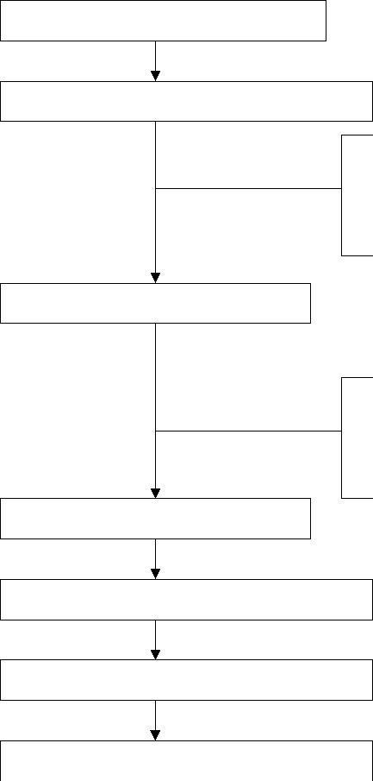

1
2
3
Downright View
Side View
Divide the unwanted cable
into two parts: A and B
Roll them up:
*Roll in the same direction.
*Roll in same number of
turns.
Roll A and B in Overlap A and B, and
Explanation
right-about directions tie overlapped
the
of each other. plate to keep it tight.
*Roll
with
the
same
diameter.
4．If power switch trips itself, it shows machine goes broken. Shouldn’t cloze the switch before
proper examination, or the broken will be increased, should contact us.
5. Abnormal Indicating Light
If it’s on, should check the main points according to the after parts.
6. Duty Cycle:
This machine’s rated duty cycle is 35%, it means: 10 minutes is a period, do welding at rated
current for 3.5 minutes, and left 4 minutes is for No-load. When doing actual welding, due to
different duty cycle, so the applicable current is different, see following form:
Type
TA-200
200
TA-250
250
TA-315
315A
TA-500
500A
Duty Cycle
Current
70%
85%
152
118
191
148
240A
185A
380A
295A
100%
7. Deposit Storage
When deposit storage, for safety’s sake, should deposit less than 3 layers, and use cables to
firm it. If moving them, should deposit less than 2 layers, and use cables to firm them.
8． If welder is put on slop, should prevent it may sway down.
9. Should not use welding machine to do thaw.
10. Environment Requirement
The machine protecting grade is IP21，should use under the following environment:
● Dry room without dust（never use in rain）；
● Temperature around between-10°C～40°C；
11
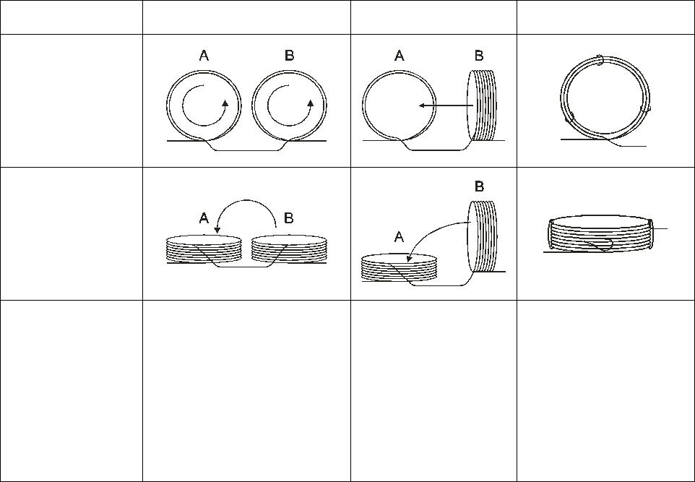

● Relative air humidity
40°C：≤50%；
20°C：≤90%。
● Dust or acid or erosive substances shouldn’t transcend normal quantity, except the one
generated from welding.
● Height above sea level should transcend 1000m。
● The space distance between wall shouldn’t less than 20cm。
● Without abnormal vibration or surge.
● When two or more than two welders are put in parallel use, the space distance between
machines shouldn’t less than 30cm.
● Should avoid been exposed to rain or snow during transit and storage, the store house
should keep air ventilated well, without erosive gas or dust.
8、 Welding Reference Value
1. Relationship between welding current, tungsten diameter and Argon gas flow:
Welding Current (A)
5～15
Tungsten Diameter (mm)
Argon Gas Flow (L/min)
0.5
1.0
1.6
2.0
2.4
3.2
4.0
4.8
3～7
4～8
10～65
55～120
6～9
85～150
6～10
7～10
10～15
12～20
15～25
120～200
200～320
320～400
400～640
2. Welding Parameters For Stainless Steel (SUS304):
Steel
Thickness
(mm)
Tungsten
Diameter
(mm)
Wire
Diameter
(mm)
Welding
Current
(A)
Argon Gas
Flow
Space
Space
Shape
(L/min)
(mm)
1
0.6
1.0
1.5
2.5
3.0
4.0
5.0
6.0
8.0
12.0
1.0～1.6
1.0～1.6
1.0～1.6
1.6～2.4
1.6～2.4
2.4
0～1.0
0～1.6
15～30
25～30
4～5
4～7
a、b
a、b
b
1
0～1.6
50～70
6～9
1
1.6～2.4
1.6～2.4
1.6～2.4
2.4～3.2
2.4～3.2
3.2～4.0
3.2～4.0
65～95
6～9
1
b
90～120
110～150
120～180
150～200
160～220
180～240
7～10
10～15
10～15
10～15
12～18
12～18
1～2
2～3
2～3
3～4
4～5
6～8
b、c
c、d
c、d
c、d
d
2.4～3.2
2.4～3.2
3.2～4.0
3.2～4.0
d
3. Welding Parameter For Aluminum:
Aluminum
Thickness
Tungsten
Diameter
Wire
Diameter
Welding
Current
Argon Gas
Flow
Space
Shape
Space
11

(mm)
0.6
1.0
1.5
2.5
3.0
4.0
5.0
6.0
8.0
(mm)
(mm)
(A)
(L/min)
4～5
(mm)
1
1.0～1.6
1.0～1.6
1.0～1.6
1.6～2.4
1.6～2.4
2.4
0～1.0
25～40
a、b
a、b
b
0～1.6
40～60
4～7
1
0～1.6
60～90
6～9
1
1.6～2.4
1.6～2.4
1.6～2.4
2.4～3.2
2.4～3.2
3.2～4.0
80～120
100～160
130～200
150～250
200～280
200～300
6～9
1
b
7～10
10～15
10～15
10～15
12～18
1～2
2～3
2～3
3～4
4～5
b、c
c、d
c、d
c、d
d
2.4～3.2
2.4～3.2
3.2～4.0
(a)
(b)
(d)
Space Shape
(c)
9、Maintain and Check
Make sure of safe use, should maintain and check
periodically. When checking the outer and inner terminals should
power off the input Distribution Box at first.
1．Daily attention points
If find out abnormal during checking following items, should contact professional person:
（1） Abnormal vibration, noise or smell？
（2） Whether connections of cables are heated.
（3） After turn on power switch, whether fan can turn normally.
（4） Whether switch is broken.
（5） The connection and insulation of cables are correct or not.
（6） Whether cables are broken or not.
2．The items to check each 3～6 months
（1） Electrical connection
Check input and side connection of output cable, whether the fixing screws are
loose or is poorly insulated.
11
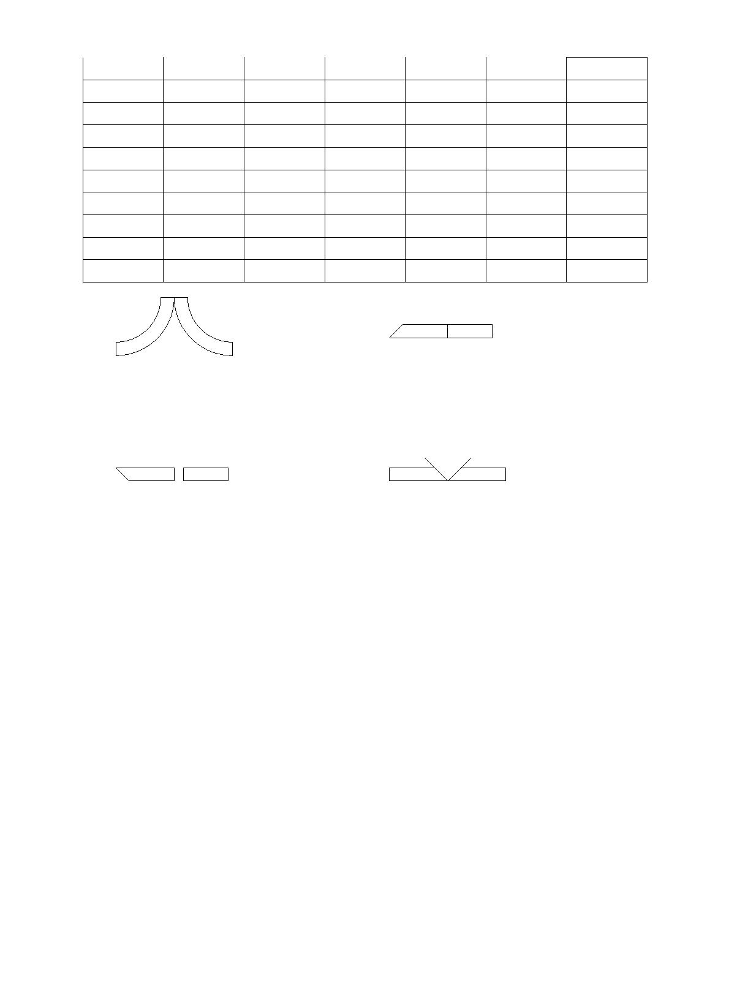

（2） Connect ground
Make sure machine body connects ground.
（3） Machine inside
If heat radiator is covered by dust, will affect heat radiation, the semi-conduct
power element will be affect too. Also the dust accumulated on transformer winding
will affect insulation, so should take apart coves of machine and use dry compressed air
to clear off the inside of machine at lease once 6 months.
After cleaning the inside of machine, should install the taken covers before using
welder again. Attention，if don’t install the taken cover, the fan will lose efficiency, and
the transformer and semi-conduct power elements would be broken down.
If welder is just power off, shouldn’t check machine
immediately, should check 5 minutes later after power switch and
switch of Distribution Box is turned off, so inside capacitor can
discharge electricity.
10、Key Point For Check During Abnormal
Broken Condition
Can’t generate Arc
Reason
Torch switch fails, torch connection cable is broken up.
Fuse blows out or switch of Distribution Box fails.
Workpiece connection cable is connected poorly.
Torch cable is broken.
Cable connection is loose.
Can’t strike arc or arc is not
stable.
Protective gas is mixed with air.
Gas flow is not enough.
Time for Delay Gas Cutoff is too short.
The workpiece is dirty with grease.
Tungsten surface is dirty.
Welding surface is poor or
not good.
Current is set to over high.
Protective gas is mixed with air.
Torch and earth connection are connected conversely.
Alumina Clearing Effect is set to high.
Tungsten is too small.
Tungsten is worn out too
quickly.
11

e

