Equipment Innovations

Owners Manual:
PTA-500
For 3 in 1 Plasma Cutter/TIG/MMA Welder Model:

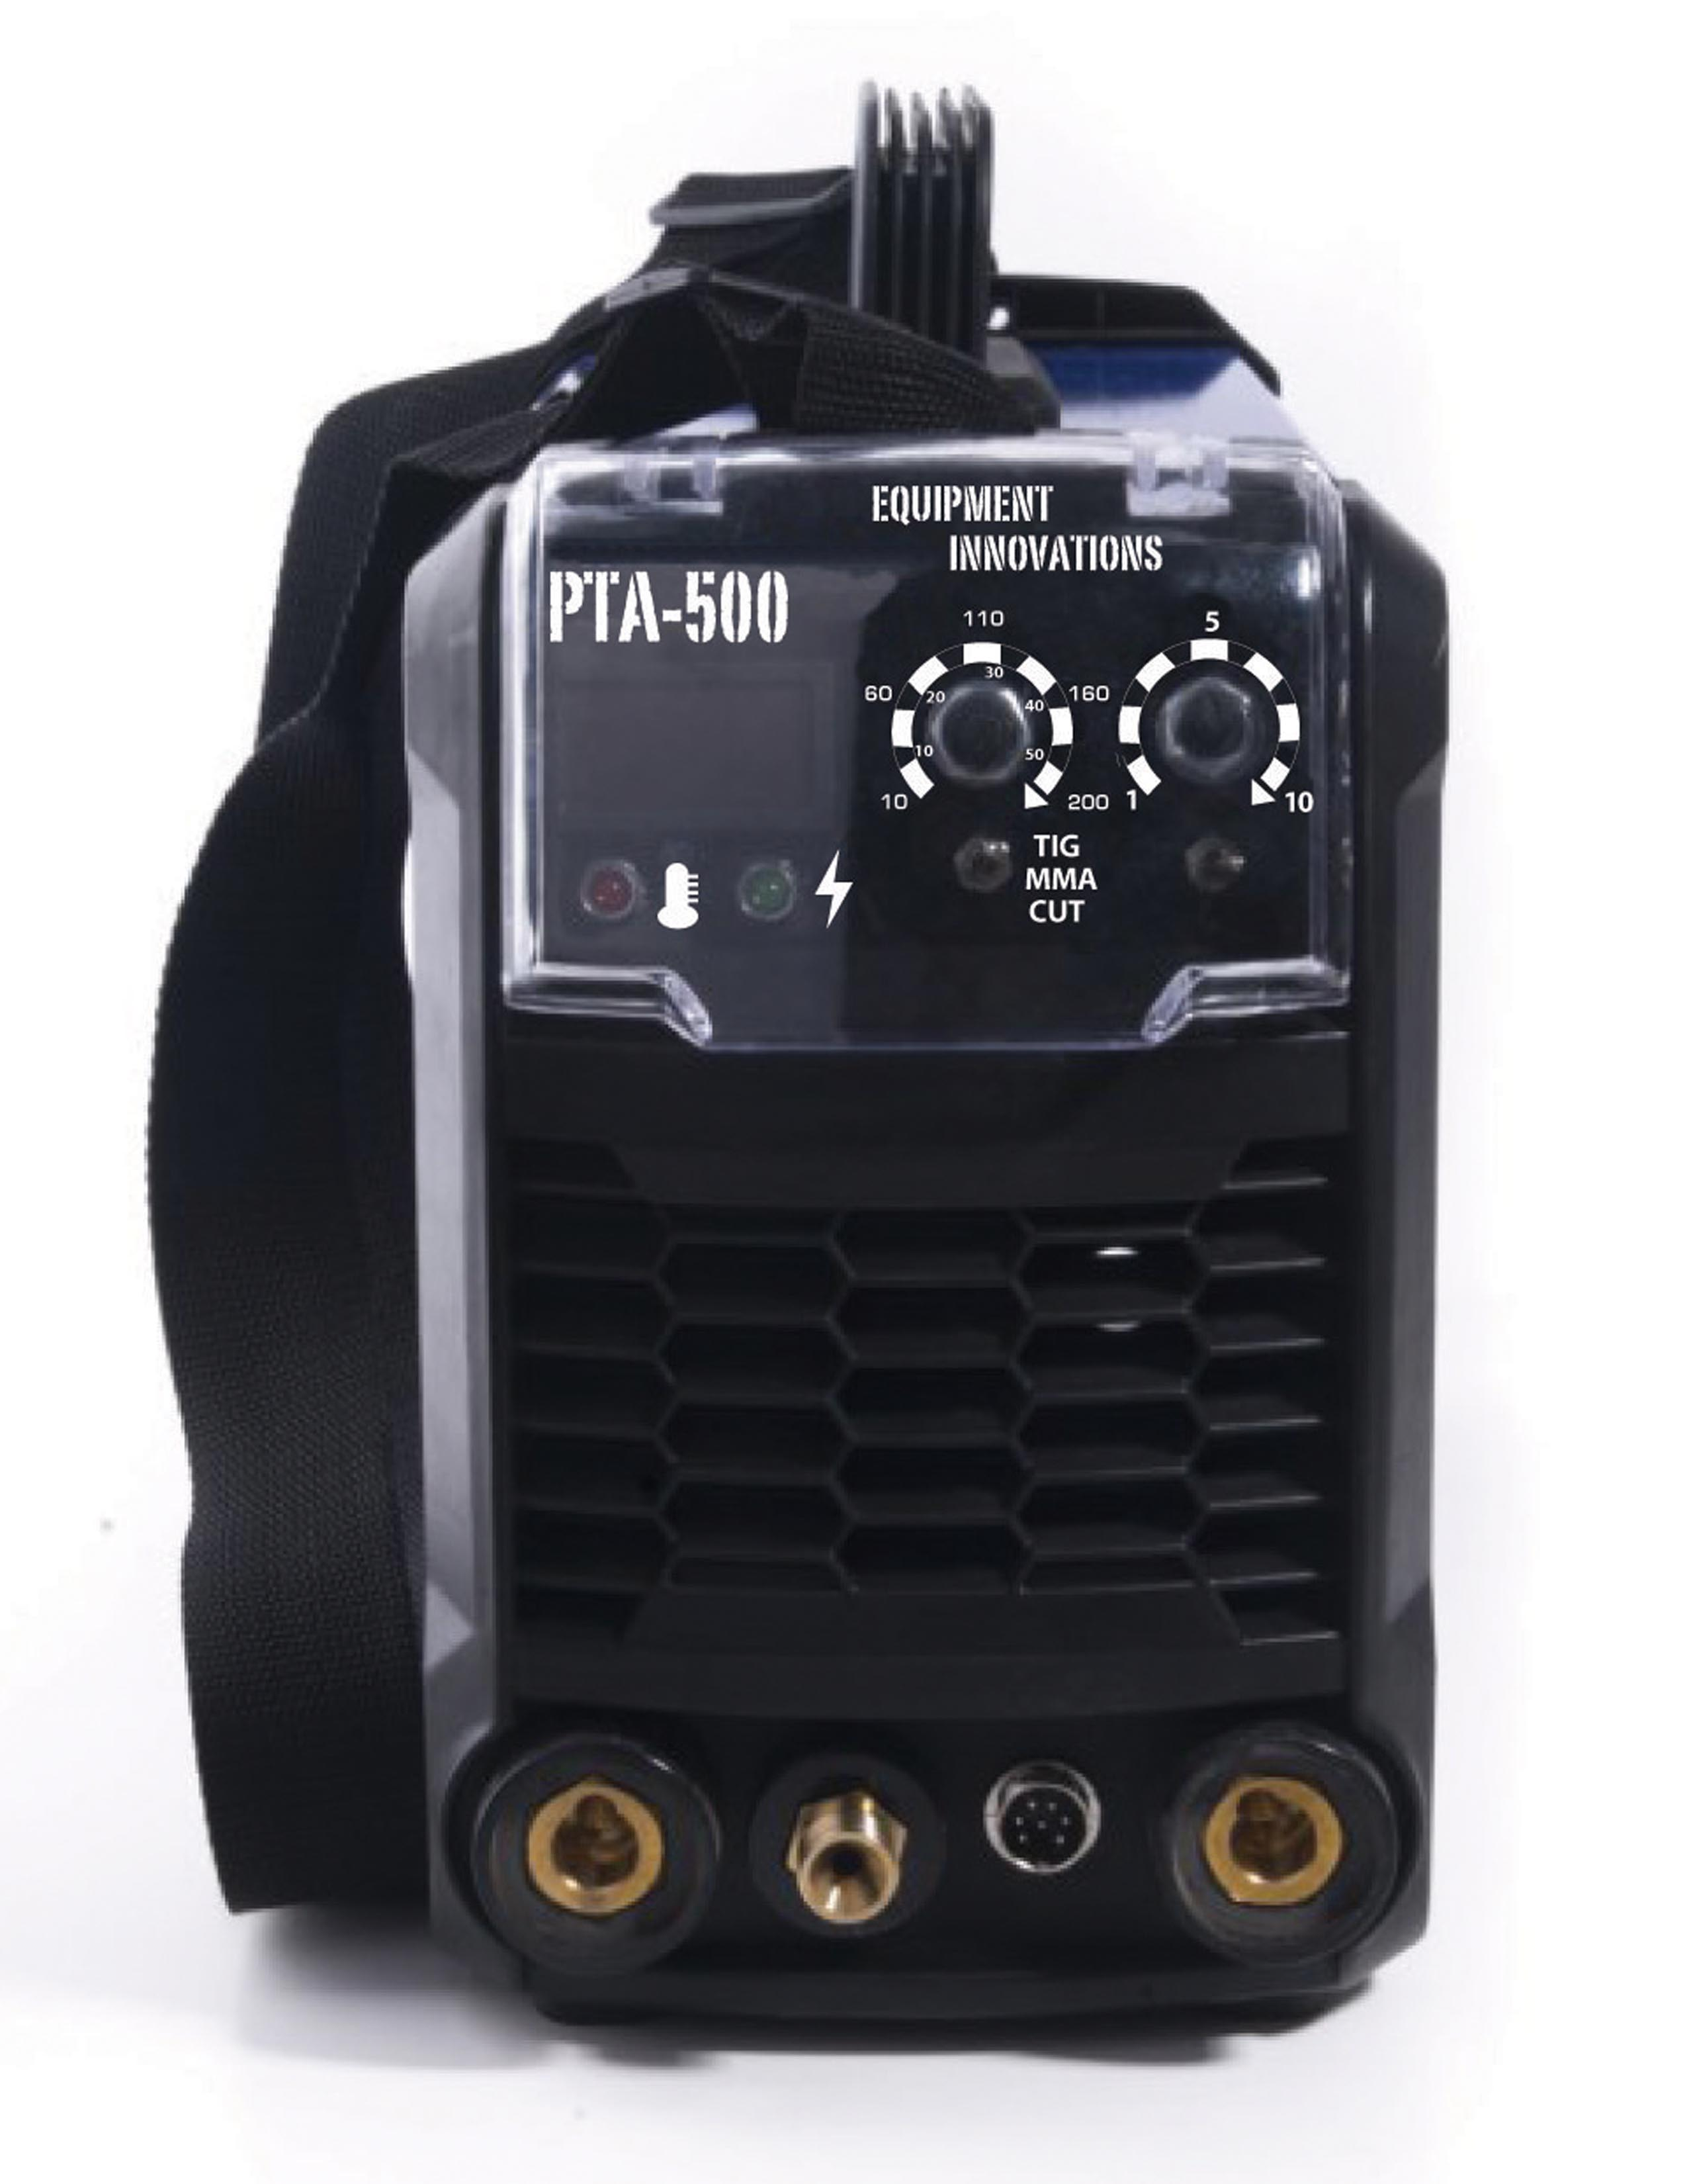

Important Note!!
Before operating this equipment read the manual fully.
WARNING !!!
This equipment uses high voltage electrical current and produces extremely high temperatures. Misuse of this machine could result in fire, destruction of property, severe injury, or even death. Only qualified individuals should install, operate, or service this machine. All national, state, and local laws and restrictions must be followed.

SAFETY PRECAUTIONS !!!

- Cutting may cause fire and explosion
- Keep children away
- Wear approved eye protection
- Wear approved respirators
- Wear approved gear, jackets, pants, boots, gloves etc.
- Do NOT wear wet or damp clothing
- Use with proper ventilation
- Do NOT use near combustibles or explosives
- Do not inhale fumes produced by this machine
- Only use in an area with approved ventilation
- Flying sparks may cause fire and burns
- Protect yourself, others, and the area from flying sparks
- Always have a fire extinguisher nearby
- Be aware that cutting on a ceiling or floor can cause fire on the opposite side
- Never cut closed containers such as drums or tanks, this may result in explosion
- Connect the ground cable as close to the work as possible
- Never cut a container with anything inside, this could result in explosion or fire

- Clean all material before cutting
- Do not cut near explosive dust or other vapors
- Never cut a pressurized pipe, cylinder or vessel.
- Follow all OSHA and NFAP requirements/regulations
- Inspect all connections and cables before and after each use. Do not use the equipment if damage is present.
- Insulate work clamp when not attached to the work
- Turn off equipment when not in use
- Electric shock may be fatal
- Never touch live electric parts
- Insulate yourself from the ground with proper protection
- Do NOT touch the torch’s parts if its in contact with the work or ground
- Disconnect the machine from its input power supply before servicing, checking or cleaning.
- SIGNIFICANT DC VOLTAGE REMAINS IN INVERTER POWERSOURCES AFTER THE MACHINE HAS BEEN DISCONNECTED FROM THE INPUT POWER.
  - Be sure the voltage of the internal capacitors reaches zero before touching any internal parts
- ARC RAYS can burn eyes and skin, always wear ANSI approved face and eye protection when cutting or watching
- DO NOT change the function of the machine while in use!
  - This may cause damage to the machine
- NOISE MAY DAMAGE HEARING
  - Use approved ear plugs
  - Warn others nearby of a possible noise hazard

INSTALLATION
- Input Power
  - This machine has automatic voltage detection for 110/220V
- Input Wiring
  - Improper wiring may cause internal damage to the machine and will void any warranty.
    - For 110V
      - Black = Live
      - White = Neutral
      - Yellow/Green = Earth or Ground
    - 220V
      - Black = Live
      - White = Live
      - Yellow/Green = Earth or Ground
- Plasma Torch Assembly
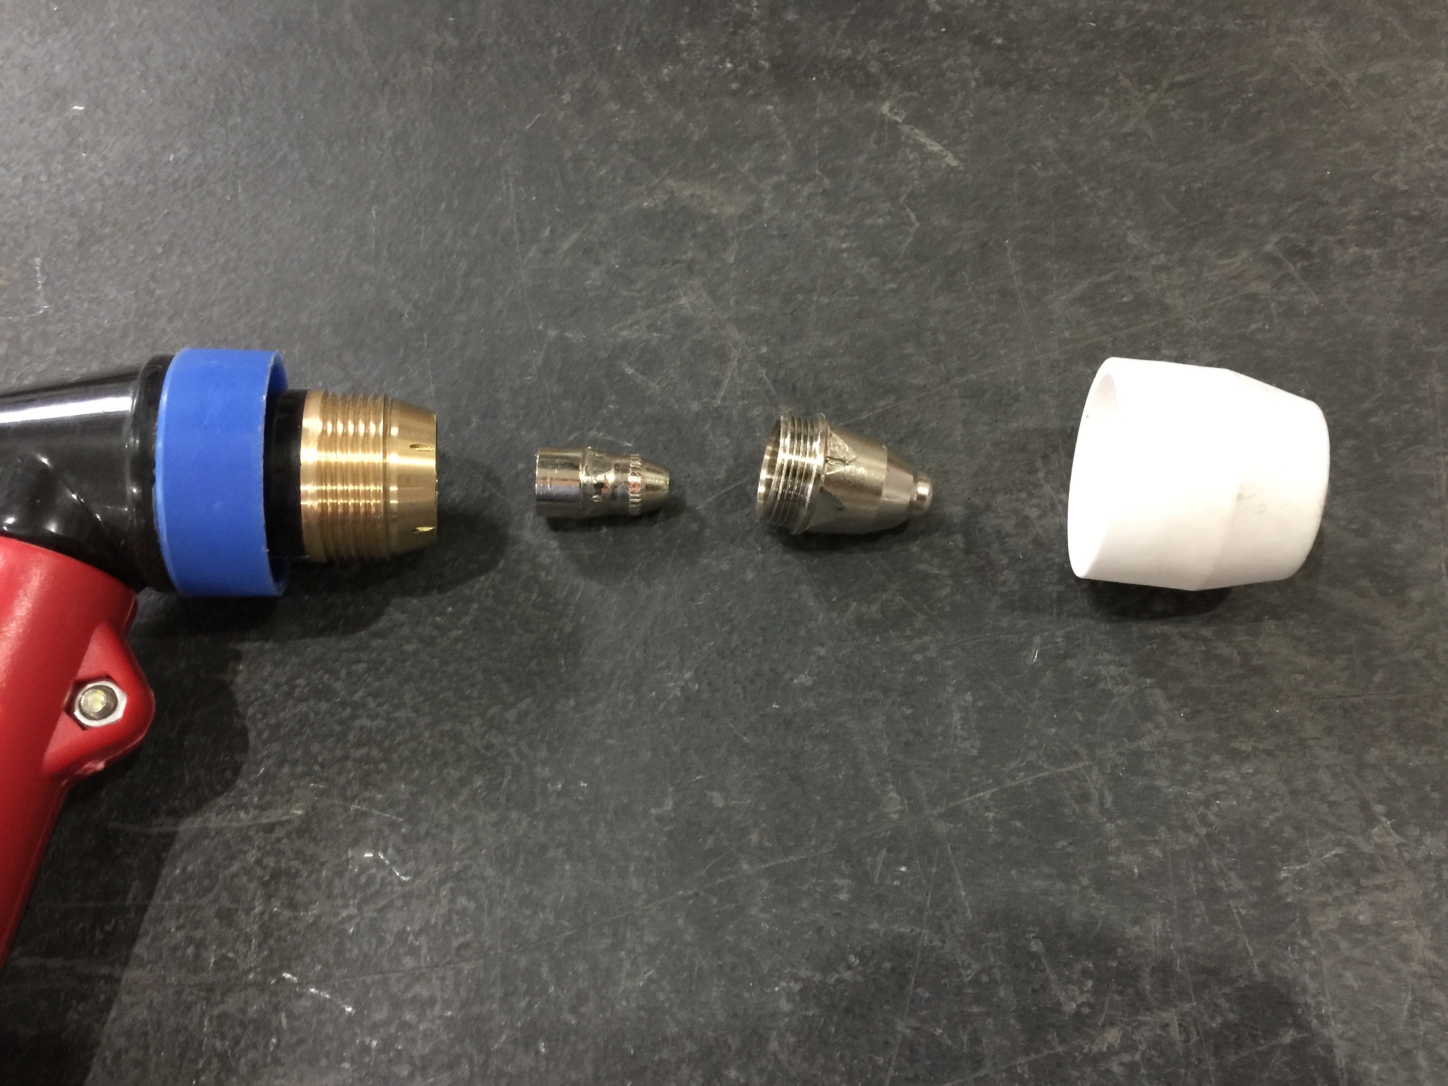

  - This machine uses compressed air as the cutting gas.
  - DO NOT use anything other than compressed air
  - Acceptable air pressure is 50-80psi
  - Recommended most effective is 60psi

- Installation Diagram

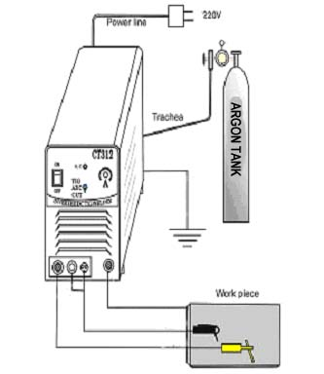

AIR REGULATOR SETUP
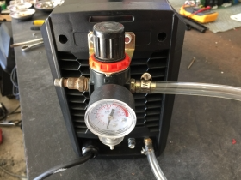

TORCH ATTACHMENT

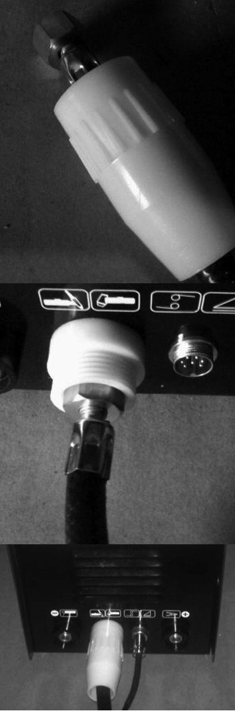
Torch attachment should only be done with the machine turned OFF.
- Slide the insulation piece over the torch cable as shown.

- Connect the torch cable to the machine as shown.

- Connect the insulation piece to the machine as shown.

TIG FUNCTION
- Connect the argon hose to the brass nozzle on the back of the machine
- Note when using the PLASMA CUTTING function the argon hose will need to be disconnected and the compressed air will then need to be connected in its place
- Connect the TIG torch to the front of the machine
- Connect the Ground clamp the front of the machine
- Selector Switch should be set to TIG (Up Position)
- Argon gas should be on and set to the correct pressure
- This machine has an electromagnetic valve that works when you press the button on the torch. When you press the button down you will be able to hear the HF spark and the argon will begin to flow out of the torch
- Set the current to the appropriate current needed
- TIG is adjustable from 10-200A
- Use the Postflow Adjustment knob to regulate how long the gas will continue to flow after the trigger is released.
- ***IF A FOOT PEDAL IS NOT BEING USED THE FOOT PEDAL SWITCH MUST BE SET TO THE OFF POSITION***

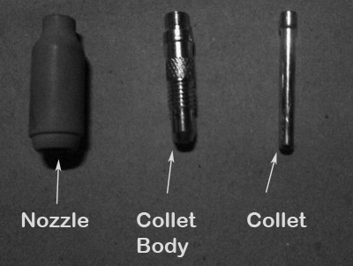

MMA/ARC FUNCTION
- Connect the MMA clamp to the front of the machine
- Foot Pedal Switch must be set to OFF
- Connect the Ground clamp to the front of the machine
- Selector Switch should be set to MMA (Middle Position)
- MMA/ARC is adjustable from 10-200A

CUT FUNCTION
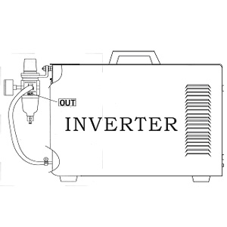

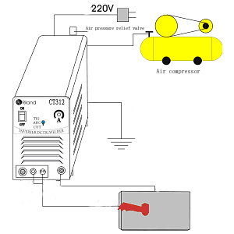
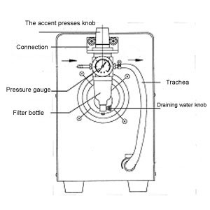
- Connect as shown above
- Foot Pedal Switch must be set to OFF
- If your machine has the air pressure gauge in the front, then there will be two outputs on the air regulator. One output will go for the air pressure gauge, while the second output will go into the brass nozzle on the back of the machine with a hose.
- Connect the torch to the front of the machine
- Connect the ground clamp to the front of the machine
- Selector Switch should be set to CUT (Down Position)
- Current is adjustable 10-50A
MAINTENANCE
- Each Use
  - With the power turned off. Before and after each use inspect the machine and its torch.
  - Replace or repair any worn part prior to use.
  - A worn out tip is characterized by an oversized or elongated orifice.
  - If the electrode is recessed greater than 1/8” it should be replaced.
  - If the shield cup is not able to be put on easily it may need to be replaced.
- On a weekly basis the machine should be blown out for dust

TROUBLESHOOTING:
Note: The foot pedal switch should be set to OFF at all times unless using a foot pedal. The foot pedal switch is located on the front of the machine, it is a black switch with a triangle logo next to it.
Problem | Cause | Solution
Torch doesn’t turn on | Power switch is fff  Problem with air supply  Ground clamp not attached | Turn power switch ON  Check air supply  Properly attach ground clamp
Sparks Shooting Upward | Plasma torch not piercing material  Torch is too far from material  Improper grounding of material  Speed | Increase the current.  Decrease the distance between the torch and cutting stock  Properly attach the ground clamp or move ground clamp closer to work  Slow down and reduce cutting speed
Dross build up | Material/tool is too hot  Current is too high  Cutting speed is too slow  Worn out torch parts | Allow time for material/tool to cool down  Reduce current  Increase cutting speed  Turn machine off. Inspect and replace consumables as necessary.
Arc stops during cut | Cutting speed is too slow  Torch is too far from material  Worn out torch parts  Improper grounding of material | Increase cutting speed  Decrease the distance between the torch and the stock  Turn machine off. Inspect and replace consumables as necessary.  Properly attach the ground clamp or move ground clamp closer to work
Low penetration | Cutting speed is too fast  Torch is tilted too far  Metal too thick  Worn out torch parts | Reduce cutting speed  Adjust torch position  More than one pass may be needed  Input current of machine may be insufficient  Turn off machine. Inspect and replace consumables as necessary.
Consumables wear out too quickly | Unit capability is exceeded  Pilot Arc time is excessive  Improper air supply | If the material is too thick you should increase the torch angle to prevent blowback into the tip of the torch  The maximum recommended time for pilot is 5 seconds.  Check air supply, operating pressure should be ~60psi  Check your air compressor

